

Analyze and model data warehouse for airline system

Analyzing and Data Warehouse Modeling Project



**MADE BY:**

Dina Hosny

Fatma Nabil

kareem beltagy

mohamed labib

Introduction: 2

Dimensional Modeling Process: 2

1- Business process: 2

2- Granularity: 2

3- Dimensions Tables: 2

4- Facts Tables: 2

Project Processes: 3

Schema Type: 3

Process Diagram: 3

Logical Model: 3

Tables Identifications: 5

1- Passenger Dimension. 5

2- Flight Dimension. 5

3- Date Dimension. 5

4- Class Dimension. 5

5- Reservation Channel Dimension. 5

6- Fare Base Dimension. 5

7- Hotel Dimension. 5

8- Customer Services Dimension. 6

9- Interaction Dimension. 6

10- Reservation Fact. 6

11- Transit Hotel Fact. 6

12- Customer Care Fact. 6

Assumptions: 7

Physical Model: 7

Insert Dummy Data into The Physical Tables: 13

Insert The Measured Data Into Fact Tables 19

SQL Queries to Answer Business Questions: 23

Introduction:

The project’s purpose is to analyze the flight activities of some airline companies and their frequent flyers and model its data warehouse schema.

Dimensional Modeling Process:

1. Business process:

Analyze the Airlines flights activities.

1. Granularity:

Per Reservation.  
  
**NOTE:** Customer Care contains transactions that can be committed before any reservation processes like making an interaction before the flight reservation. In this case and for this business process, the granularity will be Per Each Interaction.

1. Dimensions Tables:
2. Passenger Dimension.
3. Flight Dimension.
4. Date Dimension.
5. Class Dimension.
6. Reservation Channel Dimension.
7. Fare Base Dimension.
8. Hotel Dimension.
9. Interaction Dimension.
10. Customer Services Dimension.
11. Facts Tables:
12. Reservation Fact.
13. Transit Hotel Fact.
14. Customer Care Fact.

Project Processes:

Schema Type:

**Galaxy Schema:** The business process required more than one fact table to represent different processes.

Process Diagram:

Using **Kimball’s** Philosophy.



There will be one row in each fact table for each different transaction collected from passengers. The dimensionality associated with this data is quite extensive. The **Role-Playing** technique is used as the date dimension table was used more than one time in the facts table as different dates.

Logical Model:

Represents the facts and dimensions tables, and the relations between them.

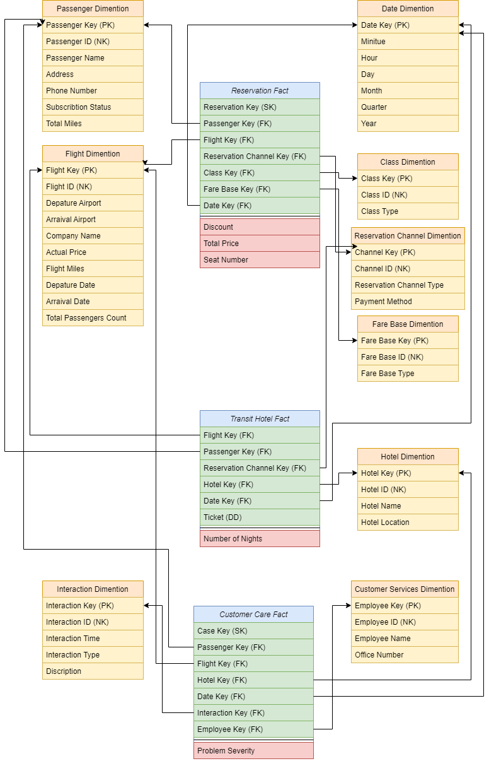

Tables Identifications:

1. Passenger Dimension.

Represents data about passengers, like passenger **Name**, **ID**, **Address**, and **Phone Number**. In addition to their **Subscription Type**: **GOLD**, **PLATINUM**, or **TITANUM** provide different benefits, and the **Total Miles** for each passenger.

1. Flight Dimension.

Represents data about the flight, like flight **ID**, **Departure Airport**, **Arrival Airport**, **Airline Company Name**, the **Miles of the Flight**, the **Departure Date**, the **Arrival Date**, and the **Total Number of Passengers** on this flight.

1. Date Dimension.

Represents the **Minute**, **Hour**, **Day**, **Month**, **Quarter**, and **Year** for each date stored for different business needs.

1. Class Dimension.

Represents the passengers’ reservation class for each flight, it can be **First Class**, **Business Class**, or **Economy Class**.

1. Reservation Channel Dimension.

Represents the channel that the ticket was purchased from. It can be **Website**, **Office**, or in the **Airport**. It also includes the payment method if it was via **Visa**, **Bank**, or **Cash**.

1. Fare Base Dimension.

Represents if the passenger fully paid the ticket price, or with a discount.  
this represents using code numbers which:

**111 means Full Fare First Class.  
112 means Discount Fare First Class.  
221 means Full Fare Business Class.  
222 means Discount Fare Business Class.  
331 means Full Fare Economy Class.  
332 means Discount Fare Economy Class.**

1. Hotel Dimension.

Represents data about the hotels that the passengers stayed on during the transit flights, like hotel **ID**, **Name,** and its **Location**.

1. Customer Services Dimension.

Represents data about the customer services employees who are responsible for customer care interactions, like employee **ID**, **Name**, and his **Office** **Number**.

1. Interaction Dimension.

Represents the passenger’s different interactions with customer services, it contains the **Interaction Time** if it was **Before**, **Within**, or **After** the flight, and the **Interaction Type** if it was **Feedback**, **Inquiry**, or **Complaint.**

1. Reservation Fact.

Represents the reservation processes and the data needed for it, it measures the **Discount** for each passenger based on his subscription:

**10% discount for GOLD subscribers.  
15% discount for PLATINUM subscribers.  
25% discount for TITANIUM subscribers.**

It also measures the **Total Price** after the discount and generates the passenger’s **Seat Number** after the reservation process is done.

1. Transit Hotel Fact.

Represents the hotel reservation process and the **Number of Nights** that each passenger stayed based on the **Arrival Time** to the hotel, and the **Departure Time** from it. Each passenger is assigned to a hotel based on the **Ticket Number** he owned.

1. Customer Care Fact.

Represents the passenger’s different interactions and the customer service’s employee who is responsible for it. It measures the **Problem Severity** based on its **Type** and **Time** to work on different interactions based on its priorities. It represents like:

**1 for Complaint Within the flight.  
2 for Complaint Before the flight.  
3 for Complaint After the flight.  
4 for Inquiry Within the flight.  
5 for Feedback Within the flight.  
6 for Inquiry Before the flight.  
7 for Feedback Before the flight.  
8 for Feedback After the flight.  
9 for Inquiry After the flight.**

Assumptions:

1. The passengers are considered as frequent flyers based on the **Number of Miles** that are assigned to their profiles.
2. The model assume that each passenger has a different subscription: **GOLD**, **PLATINUM**, or **TITANUM**. Each passenger can subscribe to one subscription that provides different benefits to him and can change it at any time.
3. The passenger table can apply the **Slowly Changed Dimension** concept on the **Subscription** attribute, that it may change its value over the time.
4. To detect if the passenger paid the ticket using a discount or not, we used the **Fare Base** dimension that stored this information for some business needs
5. The discount is computed for each passenger based on his subscription, that the **GOLD** subscribers can have a **10%** discount on their ticket price, the **PLATINUM** subscribers can have a **15%** discount on their ticket price, and the **TITANUM** subscribers can have a **25%** on their ticket price.
6. The **Total Price = Actual Price – (Discount * Actual Price)**;that the actual price is the ticket price stored in the Flight dimension, and the discount is the value that computed based on the passengers’ subscription.
7. The **Seat Number** is a unique number generated for each passenger with each reservation process.
8. The **Number of Nights = Arrival Date – Departure date** from the hotel.
9. The **Problem Severity** computes based on the **Interaction Time** and **Interaction Type**. It assumes that **Complaints** always have the highest priority even if it is before or after the flight.

Physical Model:

The creation of the tables using SQL queries. In this project, PL SQL is used for all queries.

1. Create Passenger Dimension:

CREATE TABLE passenger_dim (

passenger_key NUMBER CONSTRAINT pk_cons PRIMARY KEY,

passenger_id NUMBER CONSTRAINT unq_cons UNIQUE,

passenger_name VARCHAR(250),

address VARCHAR(250),

phone VARCHAR(250),

sub_stat VARCHAR(250),

total_miles NUMBER );

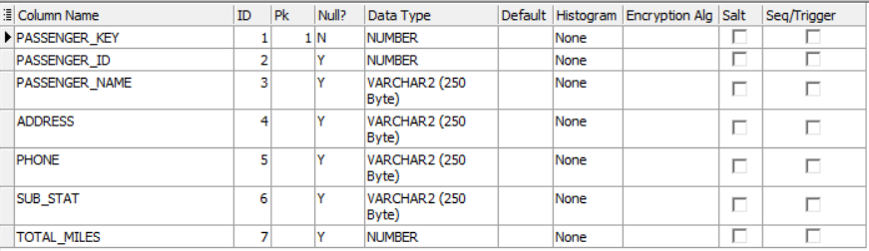

1. Create Flight Dimension:

CREATE TABLE flight_dim (

flight_key NUMBER CONSTRAINT flight_pk_cons PRIMARY KEY,

flight_id NUMBER CONSTRAINT flight_unq_cons UNIQUE,

depature_airport VARCHAR(250),

arraival_airport VARCHAR(250),

comany_name VARCHAR(250),

actual_price NUMBER,

flight_miles NUMBER,

depature_date DATE,

arraival_date DATE,

total_passenger_count NUMBER );

1. Create Date Dimension:

CREATE TABLE date_dim (

date_key NUMBER CONSTRAINT date_pk_cons PRIMARY KEY,

minitue NUMBER,

hours NUMBER,

days NUMBER,

months NUMBER,

quarter NUMBER,

years NUMBER );

1. Create Class Dimension:

CREATE TABLE class_dim (

class_key NUMBER CONSTRAINT class_pk_cons PRIMARY KEY,

class_id NUMBER CONSTRAINT class_unq_cons UNIQUE,

class_type VARCHAR(250) );

1. Create Reservation Channel Dimension:

CREATE TABLE reservation_channel_dim (

channel_key NUMBER CONSTRAINT channel_pk_con PRIMARY KEY,

channel_id NUMBER CONSTRAINT channel_unq_cond UNIQUE,

reservation_channel_type VARCHAR(250),

payment_method VARCHAR(250) );

1. Create Fare Base Dimension:

CREATE TABLE fare_base_dim (

fare_base_key NUMBER CONSTRAINT fare_pk_cons PRIMARY KEY,

fare_base_id NUMBER CONSTRAINT fare_unq_cons UNIQUE,

fare_base_type VARCHAR(250) );

1. Create Hotel Dimension:

CREATE TABLE hotel_dim (

hotel_key NUMBER CONSTRAINT hotel_pk_cons PRIMARY KEY,

hotel_id NUMBER CONSTRAINT hotel_unq_cons UNIQUE,

hotel_name VARCHAR(250),

hotel_location VARCHAR(250) );

1. Create Customer Services Dimension:

CREATE TABLE cutomer_services_dim (

employee_key NUMBER CONSTRAINT emp_pk_cons PRIMARY KEY,

employee_id NUMBER CONSTRAINT emp_unq_cons UNIQUE,

employee_name VARCHAR(250),

office_number VARCHAR(250) );

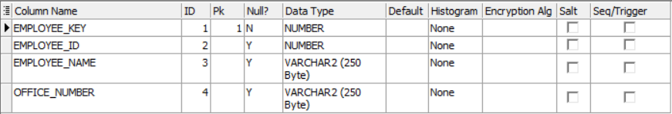

1. Create Interaction Dimension:

CREATE TABLE interation_dim (

interaction_key NUMBER CONSTRAINT inter_pk_cons PRIMARY KEY,

interaction_id NUMBER CONSTRAINT inter_unq_cons UNIQUE,

interaction_time VARCHAR(250),

interaction_type VARCHAR(250),

discription VARCHAR(250) );

1. Create Reservation Fact:

CREATE TABLE reservation_fact (

reservation_key NUMBER CONSTRAINT res_pk_cons PRIMARY KEY,

passenger_key NUMBER,

flight_key NUMBER,

reservation_channel_key NUMBER,

class_key NUMBER,

fare_base_key NUMBER,

date_key NUMBER,

discount NUMBER,

total_price NUMBER,

seat_number NUMBER );

ALTER TABLE reservation_fact

ADD (

CONSTRAINT pass_fk_cons FOREIGN KEY(passenger_key) REFERENCES passenger_dim(passenger_key),

CONSTRAINT flight_fk_con FOREIGN KEY(flight_key) REFERENCES flight_dim(flight_key),

CONSTRAINT channel_fk_cons FOREIGN KEY(reservation_channel_key) REFERENCES reservation_channel_dim(channel_key),

CONSTRAINT class_fk_cons FOREIGN KEY(class_key) REFERENCES class_dim(class_key),

CONSTRAINT fare_fk_cons FOREIGN KEY(fare_base_key) REFERENCES fare_base_dim(fare_base_key),

CONSTRAINT date_fk_cons FOREIGN KEY(date_key) REFERENCES date_dim(date_key) );

1. Create Transit Hotel Fact:

CREATE TABLE transit_hotel_fact (

flight_key NUMBER,

passenger_key NUMBER,

reservation_channel_key NUMBER,

hotel_key NUMBER,

date_key NUMBER,

ticket_number NUMBER,

number_of_nights NUMBER );

ALTER TABLE transit_hotel_fact

ADD (

CONSTRAINT flight_fk_conss FOREIGN KEY(flight_key) REFERENCES flight_dim(flight_key),

CONSTRAINT pass_fk_conss FOREIGN KEY(passenger_key) REFERENCES passenger_dim(passenger_key),

CONSTRAINT rese_fk_conss FOREIGN KEY(reservation_channel_key) REFERENCES reservation_channel_dim(channel_key),

CONSTRAINT hotel_fk_conss FOREIGN KEY(hotel_key) REFERENCES hotel_dim(hotel_key),

CONSTRAINT date_fk_conss FOREIGN KEY(date_key) REFERENCES date_dim(date_key));

1. Create Customer Care Fact:

CREATE TABLE customer_care_fact(

case_key NUMBER CONSTRAINT case_pk_cons PRIMARY KEY,

passenger_key NUMBER,

flight_key NUMBER,

hotel_key NUMBER,

date_key NUMBER,

interaction_key NUMBER,

employee_key NUMBER,

problem_severity NUMBER );

ALTER TABLE customer_care_fact

ADD (

CONSTRAINT pass_fk_consss FOREIGN KEY(passenger_key) REFERENCES passenger_dim(passenger_key),

CONSTRAINT flight_fk_consss FOREIGN KEY(flight_key) REFERENCES flight_dim(flight_key),

CONSTRAINT hotel_fk_consss FOREIGN KEY(hotel_key) REFERENCES hotel_dim(hotel_key),

CONSTRAINT date_fk_consss FOREIGN KEY(date_key) REFERENCES date_dim(date_key),

CONSTRAINT inter_fk_consss FOREIGN KEY(interaction_key) REFERENCES interation_dim(interaction_key),

CONSTRAINT emp_fk_consss FOREIGN KEY(employee_key) REFERENCES cutomer_services_dim(employee_key) );

Insert Dummy Data into The Physical Tables:

Based on the HR schema that ORACLE provides for leaning, and using some other techniques and functions, some dummy data inserted into the tables for testing and answering some business questions.

1. Class Dimension Data:

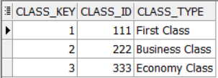

1. Customer Services Dimension Data:

1. Date Dimension Data:

1. Fare Base Dimension Data:

1. Flight Dimension Data:

1. Hotel Dimension Data:

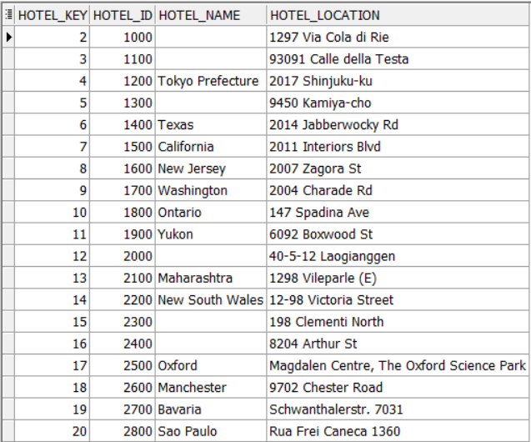

1. Interaction Dimension Data:

1. Passenger Dimension Data:

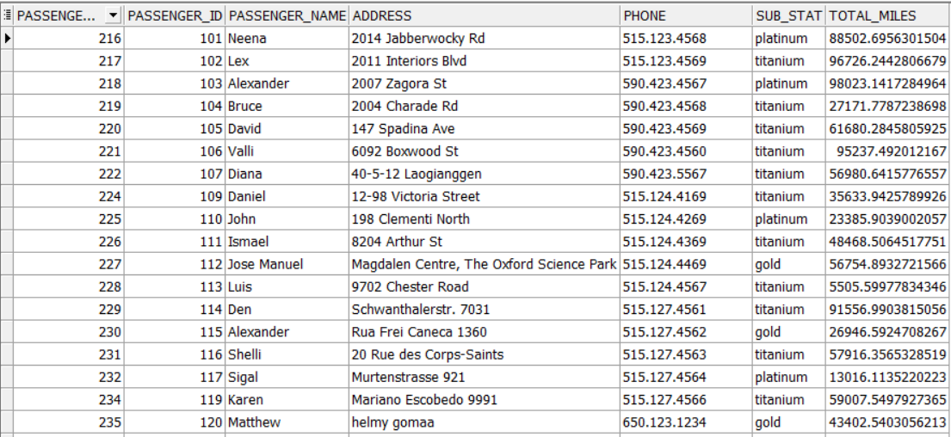

1. Reservation Channel Dimension Data:

1. Customer Care Fact Data:

1. Reservation Fact Data:

1. Transit Hotel Fact Data:

Insert The Measured Data Into Fact Tables

1. Insert Data into Discount Major in Reservation Fact:

DECLARE

v_sub VARCHAR(250);

CURSOR Cur IS

SELECT RESERVATION_KEY, PASSENGER_KEY, DISCOUNT

from RESERVATION_FACT

FOR UPDATE OF DISCOUNT;

BEGIN

FOR Rec IN Cur

LOOP

SELECT sub_stat

INTO v_sub

FROM passenger_dim

WHERE passenger_key = Rec.passenger_key;

IF(v_sub = 'gold') THEN

UPDATE RESERVATION_FACT

SET discount = 0.10

WHERE CURRENT OF Cur;

ELSIF(v_sub = 'platinum') THEN

UPDATE RESERVATION_FACT

SET discount = 0.15

WHERE CURRENT OF Cur;

ELSIF(v_sub = 'titanium') THEN

UPDATE RESERVATION_FACT

SET discount = 0.25

WHERE CURRENT OF Cur;

END IF;

END LOOP;

END;

1. Insert Data into Total Price Major in Reservation Fact:

DECLARE

v_price NUMBER;

v_discount NUMBER;

CURSOR Cur IS

SELECT RESERVATION_KEY, flight_key , total_price, discount

from RESERVATION_FACT

FOR UPDATE OF total_price;

BEGIN

FOR Rec IN Cur

LOOP

SELECT actual_price

INTO v_price

FROM flight_dim

WHERE flight_key = Rec.flight_key;

UPDATE RESERVATION_FACT

SET total_price = v_price – (v_price*Rec.discount)

WHERE CURRENT OF Cur;

END LOOP;

END;

1. Insert Data into Seat Number Major in Reservation Fact:

DECLARE

CURSOR Cur IS

SELECT flight_key , total_price, seat_number

from RESERVATION_FACT

FOR UPDATE OF seat_number;

BEGIN

FOR Rec IN Cur

LOOP

IF (Rec.flight_key IS IN (SELECT flight_key

FROM flight_dim))

THEN

UPDATE RESERVATION_FACT

SET seat_number = TRUNC(***dbms_random.value***(1,300),0)

WHERE CURRENT OF Cur;

END IF;

END LOOP;

END;

1. Insert Data into Number of Nights Major in Transit Hotel Fact:

DECLARE

v_date DATE;

CURSOR Cur IS

SELECT FLIGHT_KEY ,NUMBER_OF_NIGHTS

from TRANSIT_HOTEL_FACT

FOR UPDATE OF NUMBER_OF_NIGHTS;

BEGIN

FOR Rec IN Cur

LOOP

SELECT arraival_date

INTO v_date

FROM flight_dim

WHERE flight_key = Rec.flight_key;

UPDATE TRANSIT_HOTEL_FACT

SET NUMBER_OF_NIGHTS = TRUNC(SYSDATE - v_date ,0)

WHERE CURRENT OF Cur;

END LOOP;

END;

1. Insert Data into Problem Severity Major in Customer Care Fact:

DECLARE

v_type VARCHAR(250);

v_time VARCHAR(250);

CURSOR Cur IS

SELECT CASE_KEY ,PROBLEM_SEVERITY, INTERACTION_KEY

from CUSTOMER_CARE_FACT

FOR UPDATE OF PROBLEM_SEVERITY;

BEGIN

FOR Rec IN Cur

LOOP

SELECT INTERACTION_TIME, INTERACTION_TYPE

INTO v_time, v_type

FROM INTERATION_DIM

WHERE INTERACTION_KEY = Rec.INTERACTION_KEY;

IF (v_time = 'within flight' AND v_type = 'complaint')

THEN

UPDATE CUSTOMER_CARE_FACT

SET PROBLEM_SEVERITY = 1

WHERE CURRENT OF Cur;

ELSIF (v_time = 'before flight' AND v_type = 'complaint')

THEN

UPDATE CUSTOMER_CARE_FACT

SET PROBLEM_SEVERITY = 2

WHERE CURRENT OF Cur;

ELSIF (v_time = 'after flight' AND v_type = 'complaint')

THEN

UPDATE CUSTOMER_CARE_FACT

SET PROBLEM_SEVERITY = 3

WHERE CURRENT OF Cur;

ELSIF (v_time = 'within flight' AND v_type = 'inquiry')

THEN

UPDATE CUSTOMER_CARE_FACT

SET PROBLEM_SEVERITY = 4

WHERE CURRENT OF Cur;

ELSIF (v_time = 'within flight' AND v_type = 'feedback')

THEN

UPDATE CUSTOMER_CARE_FACT

SET PROBLEM_SEVERITY = 5

WHERE CURRENT OF Cur;

ELSIF (v_time = 'before flight' AND v_type = 'inquiry')

THEN

UPDATE CUSTOMER_CARE_FACT

SET PROBLEM_SEVERITY = 6

WHERE CURRENT OF Cur;

ELSIF (v_time = 'before flight' AND v_type = 'feedback')

THEN

UPDATE CUSTOMER_CARE_FACT

SET PROBLEM_SEVERITY = 7

WHERE CURRENT OF Cur;

ELSIF (v_time = 'after flight' AND v_type = 'feedback')

THEN

UPDATE CUSTOMER_CARE_FACT

SET PROBLEM_SEVERITY = 8

WHERE CURRENT OF Cur;

ELSIF (v_time = 'after flight' AND v_type = 'inquiry')

THEN

UPDATE CUSTOMER_CARE_FACT

SET PROBLEM_SEVERITY = 9

WHERE CURRENT OF Cur;

END IF;

END LOOP;

END;

SQL Queries to Answer Business Questions:

1. Find the Most Common Arrival Destinations:

SELECT ARRAIVAL_AIRPORT, COUNT(ARRAIVAL_AIRPORT) AS "Number of Visits"

FROM flight_dim

GROUP BY ARRAIVAL_AIRPORT

ORDER BY COUNT(ARRAIVAL_AIRPORT) DESC;

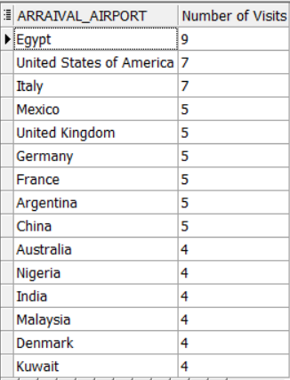

1. Find the Interactions with Type “Complaint” and the Employee Who Works on It:

SELECT i.INTERACTION_TYPE, i.DISCRIPTION, c.EMPLOYEE_NAME

FROM INTERATION_DIM i JOIN CUSTOMER_CARE_FACT f

ON i.INTERACTION_KEY = f.INTERACTION_KEY

JOIN CUTOMER_SERVICES_DIM c

ON F.EMPLOYEE_KEY = C.EMPLOYEE_KEY

WHERE I.INTERACTION_TYPE = 'complaint';

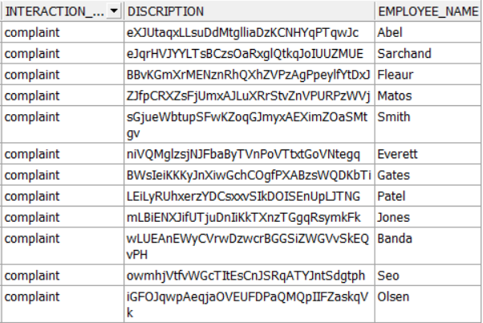

1. Find the Top Passengers with Largest Total Miles:

SELECT PASSENGER_NAME, ROUND(TOTAL_MILES,2)

FROM PASSENGER_DIM

WHERE ROWNUM <= 10

ORDER BY TOTAL_MILES DESC;

1. Find the Total Airline Companies and Their Profit:

SELECT f.COMANY_NAME, SUM(r.TOTAL_PRICE) profit

FROM FLIGHT_DIM f JOIN RESERVATION_FACT r

ON f.FLIGHT_KEY = r.FLIGHT_KEY

GROUP BY COMANY_NAME

ORDER BY SUM(r.TOTAL_PRICE) DESC;

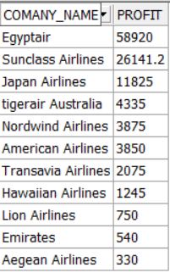

1. Find the Number of Passengers for Each Airline Company:

SELECT f.COMANY_NAME, COUNT(p.PASSENGER_KEY) "Number of Passengers"

FROM FLIGHT_DIM f JOIN RESERVATION_FACT r

ON f.FLIGHT_KEY = r.FLIGHT_KEY

JOIN PASSENGER_DIM p

ON r.PASSENGER_KEY = p.PASSENGER_KEY

GROUP BY COMANY_NAME

ORDER BY COUNT(p.PASSENGER_KEY) DESC;

1. Find the Number of Flights for Each Airline Company:

SELECT COMANY_NAME, COUNT(FLIGHT_KEY) "Number of Flights"

FROM FLIGHT_DIM

GROUP BY COMANY_NAME

ORDER BY COUNT(FLIGHT_KEY) DESC;

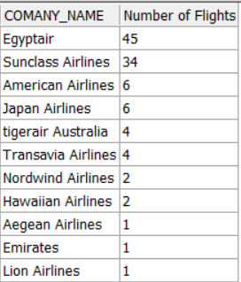

1. Find The Total Sales from Each Payment Method:

SELECT c.PAYMENT_METHOD "Payment Method", SUM(r.TOTAL_PRICE) profit

FROM RESERVATION_CHANNEL_DIM c JOIN RESERVATION_FACT r

ON c.CHANNEL_KEY = r.RESERVATION_CHANNEL_KEY

GROUP BY c.PAYMENT_METHOD

ORDER BY SUM(r.TOTAL_PRICE) DESC;

1. Find the Total Sales from Each Reservation Channel:

SELECT reservation_channel_type AS "channel type", SUM(total_price) AS "total cost"

FROM reservation_fact rf

JOIN RESERVATION_CHANNEL_DIM rd

ON rf.reservation_channel_key = rd.channel_key

GROUP BY reservation_channel_type

ORDER BY "total cost" DESC;

1. Find the Average Number of Nights That Passengers Stayed in Each Hotel:

SELECT h.HOTEL_NAME, TRUNC(AVG(n.NUMBER_OF_NIGHTS),0) "AVG number of nights"

FROM HOTEL_DIM h JOIN TRANSIT_HOTEL_FACT n

ON H.HOTEL_KEY = N.HOTEL_KEY

GROUP BY h.hotel_name

ORDER BY AVG(n.NUMBER_OF_NIGHTS) DESC;

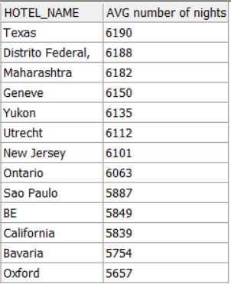

1. Find The Most Received Classes at Each Company:

SELECT comany_name AS "company" , class_type AS "class"

FROM class_dim cd

JOIN reservation_fact rf

ON CD.CLASS_KEY = RF.CLASS_KEY

JOIN flight_dim fd

ON rf.flight_key= FD.FLIGHT_KEY

GROUP BY comany_name , class_type ;

1. Find the Frequent Passengers and How Much Miles they Passed:

SELECT PASSENGER_ID,SUM( FLIGHT_MILES)as "flight miles "

FROM FLIGHT_dim

join reservation_fact on reservation_fact.flight_key = FLIGHT_DIM.FLIGHT_KEY

join passenger_dim on PASSENGER_DIM.PASSENGER_key = RESERVATION_FACT.PASSENGER_KEY

GROUP BY PASSENGER_ID;

1. Find The Percentage of Each Subscription Type:

SELECT SUB_STAT , ROUND(COUNT(SUB_STAT)/ (SELECT COUNT(*) FROM PASSENGER_dim) *100,1)||'%'

FROM PASSENGER_dim

GROUP BY SUB_STAT;

